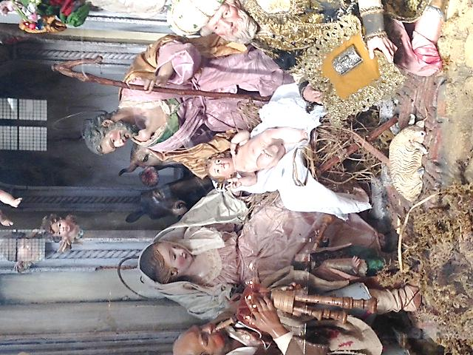
Happy Christmas 2014

“The people that walked in darkness
has seen a great light;
on those who live in a land of deep shadow
a light has shone” (Is 9,1)

Rome, December, 2014

Dear Confreres,

As we again approach the feast of Christmas, which allows us to contemplate with gratitude the gift of Jesus Christ, the source of life, light and hope, I wish to greet you also on behalf of the General Council and all the General Administration.
At the end of a year marked by many situations of suffering, pain and violence which affected us deeply in some of our missions and communities, it is not unlikely that our energy, our enthusiasm and even our faith may be going through a trying time, a time of disappointments and fatigue.
How beautiful it is to hear the words of the prophet Isaiah: “The people that walked in darkness have seen a great light”.
At a time when the world seems to become every day more complicated, and challenges seem to multiply, at a time when there are no prophets to show the right way, and everything seems to be turned upside down, at that very moment Our Lord again becomes present in our midst, in the simplicity and humility of that child, who is the son of Mary and Joseph, as the gift of God who is always relevant for our humanity. He is present in the midst of the darkening shadows that try to prevent us from seeing clearly the goal, full of promises which Our Lord never tires of accomplishing for our good, in this contradictory and sometimes confused situation that we share with a humanity in search of the pathway of justice, of truth and of peace.
We are told, through the Word we proclaim as missionaries, that God makes his light shine to remind us that we are not orphans and that he is not yet tired of pouring out his love on us.
Ringing in our ears are the words that recall that those who live in a land of deep shadow are invited to leave the darkness because God ceaselessly illuminates his creation.
We, today, are that people called to see a new light revealing the face of God in our midst. It is a light that re-awakens our confidence and strengthens our hope so that we may continue our mission in the certainty that God is preparing a new history for all of us to the extent that we realise we are poor and in need of his support.
While voices around us increasingly speak of crisis and confusion, Our Lord, through the simplicity of the mystery of his incarnation, reminds us that his faithful and ever new presence opens up sights that invite us to look at the future with eyes of optimism and enthusiasm. We are convinced that he is our light, that he is the splendour of God that is able to overcome all darkness and that it is He who continues to open the way for us towards a future that is all in his hands.
With gratitude we acknowledge the light that has shone, that overcomes the darkness and warms hearts even to the ends of the earth.
This is the reason why Christmas is our great feast. This is the reason why we wish to celebrate it as a missionary feast inviting us to receive Our Lord who comes to meet us, once again challenging us to become witnesses of his presence through the joy of our consecration and our small but generous service.
As people on a journey, we too feel called to acknowledge the light that shines in our travelling and invites us to see the goodness of God who transforms himself into strength and courage for the present and in extraordinary confidence for the future.
Christmas reminds us that we are in the time of God and the contemplation of the child Jesus, offered as God’s gift to those whom he loves. Let us accept this grace as a favourable time to live the newness and the beauty of our missionary vocation.
The light which shines for us invites us to look far into the future with the gaze of faith, with hearts full of confidence in Our Lord, ready to set out as announcers of his Word and witnesses of his presence in our midst and with hands always ready to collaborate in building up a humanity that is more fraternal, more just and more supportive.
Happy Christmas to everyone and all good wishes and blessings for the coming year.
With a fraternal embrace.

Fr. Enrique Sánchez G. mccj
Superior General

