How to Make the Most of Your Summer Vacation (for Teens)
Seven Methods: Cleaning out the old year/ Outdoor fun /Indoor fun/ Craft/ Shopping/ Relaxing/ Having friends over.
School is finally over, but what are you going to do now? The excitement of getting out of school can quickly turn into boredom and frustration about having nothing to do. Don't let this happen to you. Read on to find out how to make the most out of your summer vacation!

Method 1 Cleaning out the old year

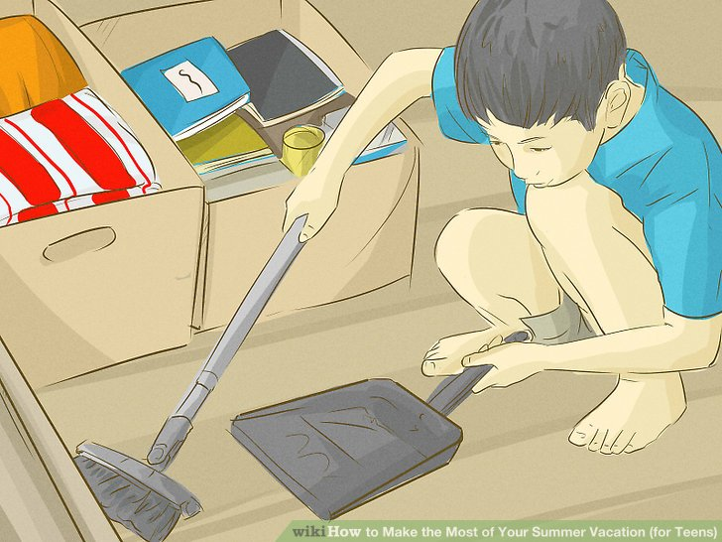

Clean your room out. Throw away, destroy (rip) or put away anything you don't need the next year. Homework, drafts, torn sheets etc.

Method 2 Outdoor fun
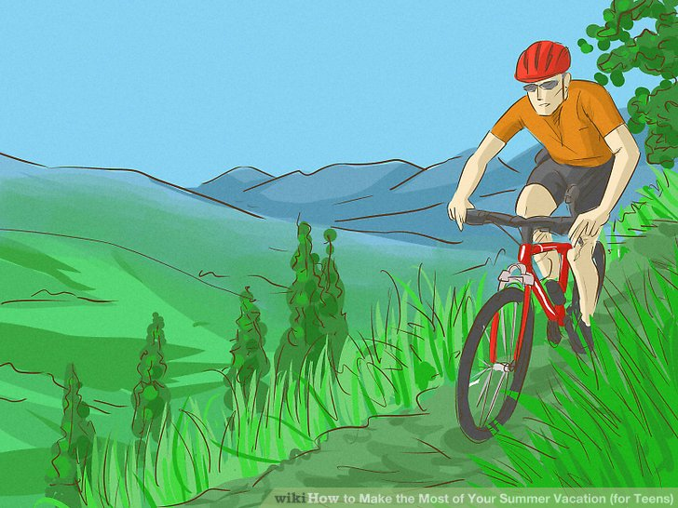
- Get outside! You've stayed inside all winter, so get out your bike and go for a nice, long ride. Grab a friend or two and go hiking. Go to the beach, lake, ocean for an afternoon of swimming and tanning. Go jogging or even just for a walk in the park or on the sidewalk.

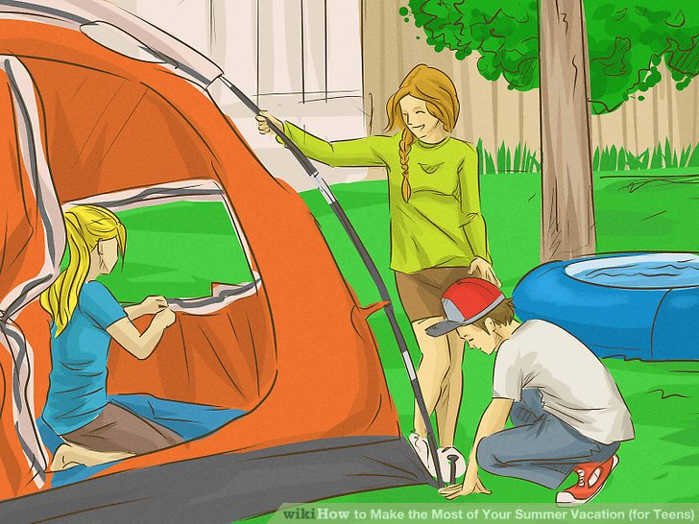

- Go camping. Gather some friends and go set up a tent somewhere. A yard, open field (if you're allowed), or a camp site are great places to set up camp. Make sure you have the necessary equipment so you're not stranded in the rain wearing shorts and sandals with nothing to do. Try to set up camp by a lake for a lovely view and easy access to swimming grounds.

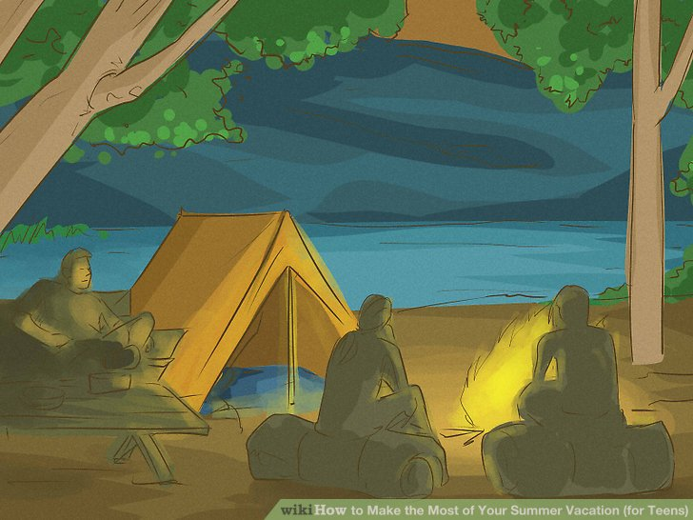

Go to a camp for a few days. After all, camp is a great place to meet new friends. Plus, there are a lot of different camps out there to choose from.

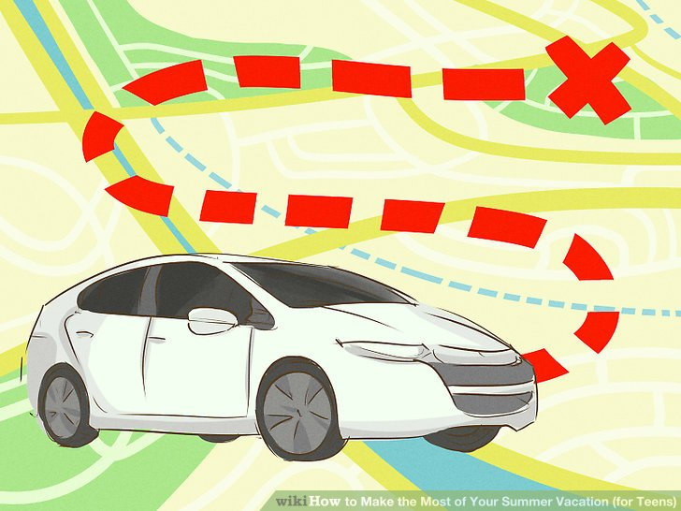

- Visit places. You don't have to go anywhere exotic, just visit somewhere in your country, state, or even in your town. Go on a road trip with your family, or go with a few friends to a local place you've never been to before.

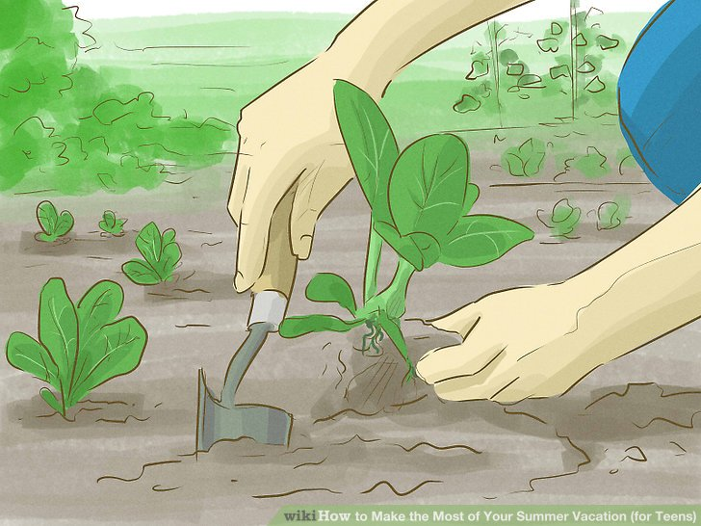

- Grow a small garden. You can grow small plants in flower pots or grow a small vegetable or fruit garden. Look up recipes for preserving your harvest, and prepare to bottle and can things at summer's end.

Method 3. Indoor fun
- Get membership at your local library. Spend some time there reading books that you like and are interested in. Novels, magazines, encyclopedias, non-fiction books, etc. and lot more are all there for you to read for free. Pick what you like and read on. Lots of libraries also have summer reading clubs, so consider joining one of those if you enjoy reading.
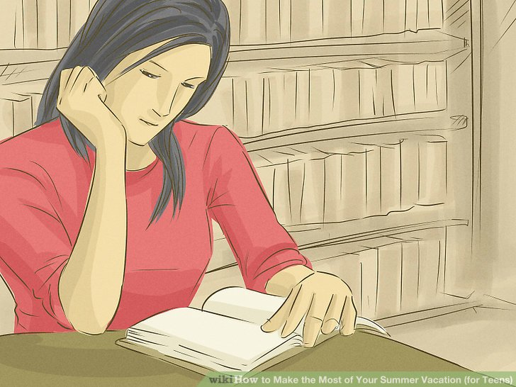

2) Learn how to cook. Cooking is a fun and delicious activity to try. Take some classes, ask your family members for help, or find a book or search in the internet for easy cooking recipes.

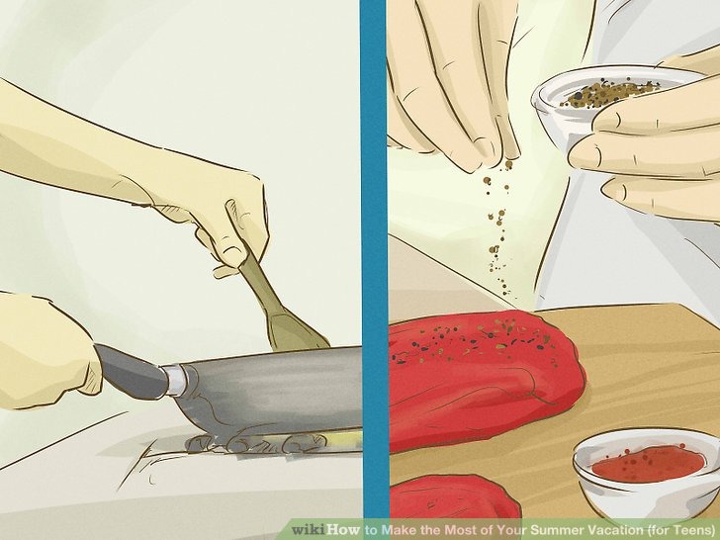

3)Listen to your favorite songs. Music will calm you down and make you feel happy. Make a summer playlist of all of your favorites to listen to while you exercise, go to the beach, or just relax at home. You'll find you end up associating certain songs with your long vacation times, so pick some good ones for good memories.

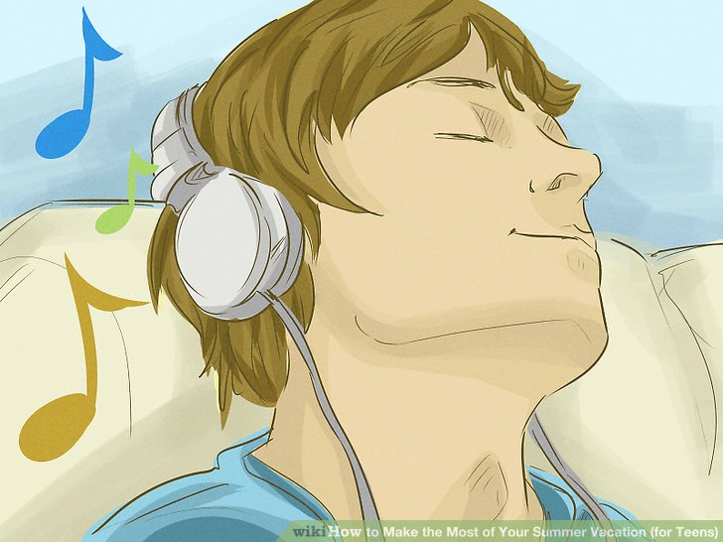

- Watch your favorite movies. Watching movies with friends is a good way to spend time with them.

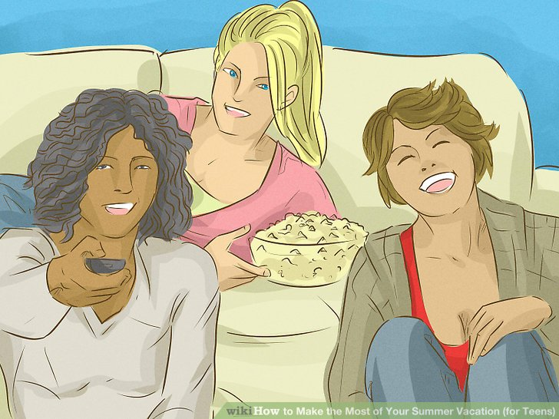

Method 4. Craft
- Make a scrapbook of the summer. Buy several disposable cameras in the beginning of summer and carry them around with you. When you go out with your friends, take a few snapshots. Buy some cheap stickers, glue sticks, glitter, etc and have fun.
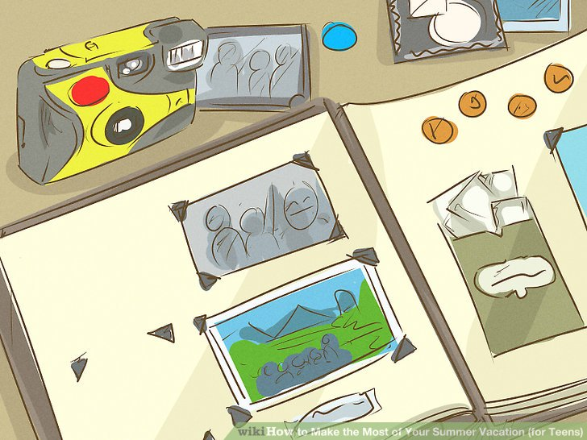

- Make crafts that you'd like to try but haven't yet. Borrow books from the library on how to make them, or use online resources. You don't need to spend a fortune on materials––see what's inside your house, at the local thrift store or in online auctions and save money.

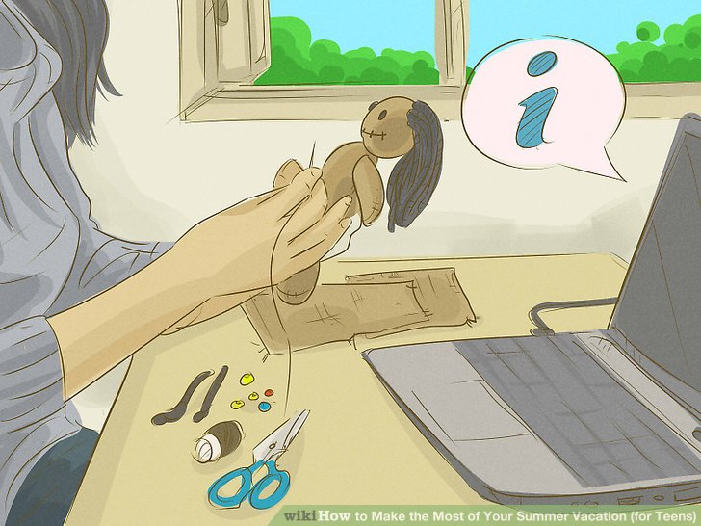

Method 5. Shopping
- Go to the mall. It's a great way to make new friends too. Hang out around the mall with your friends. Enjoy yourself even if you don't have enough money to buy anything.

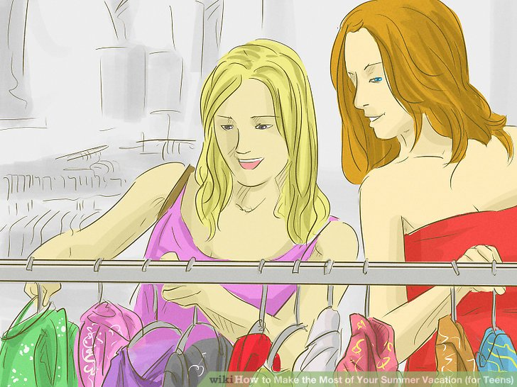

Method 6. Relaxing

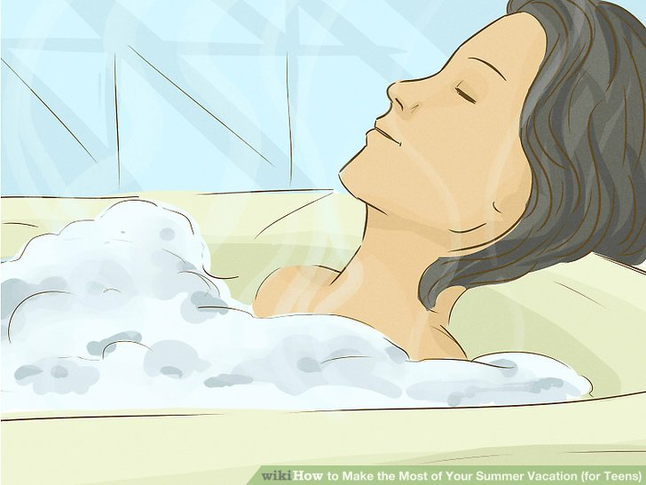

- Stay indoors once in a while and be alone. Take a nice bath, put on some pajamas, and curl up on the couch with a great book and a snack. Rent a movie or two and spend some time with yourself.

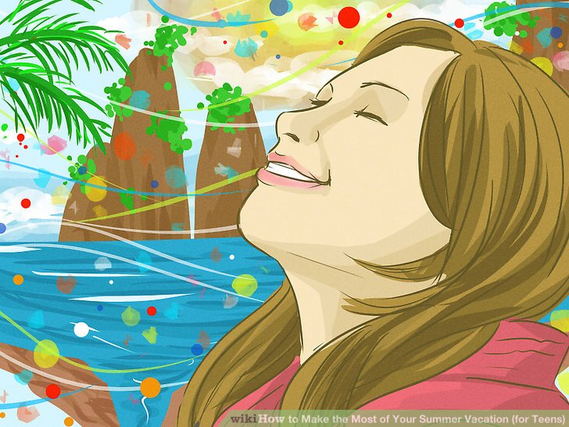

- Use your imagination and waste some time. Pretend that you're in a magical world and that you can do anything you want to do there!

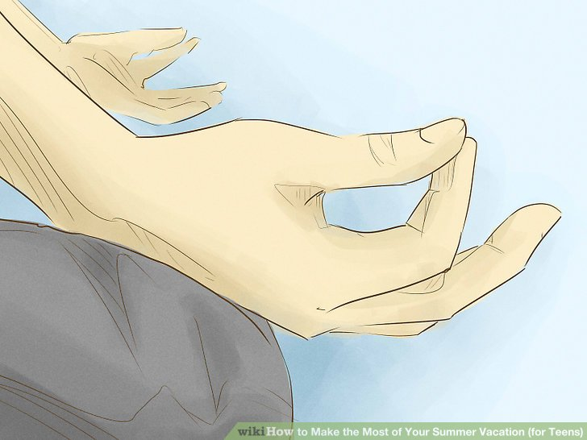

- Go to a yoga class. Yoga is a great way to keep calm and be patient. Round up some of your friends and try out a yoga class. You don't have to go to yoga classes; you could also find a book or search in the Internet to practice and try out basic and easy yoga skills.

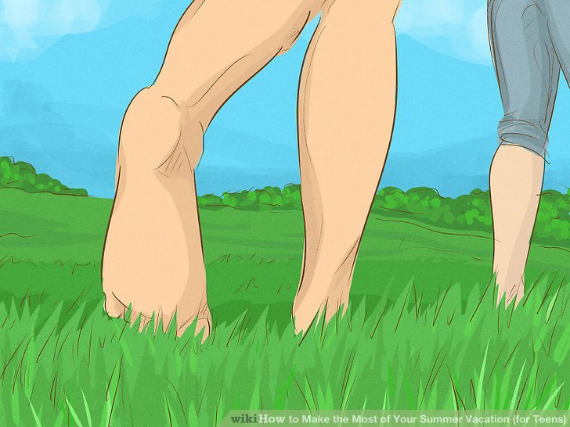

- Relax outside. You don't even have to wear shoes, so once you get outside, take them off! Being barefoot is perfect for relaxing, especially in the summer.

Method 7. Having friends over

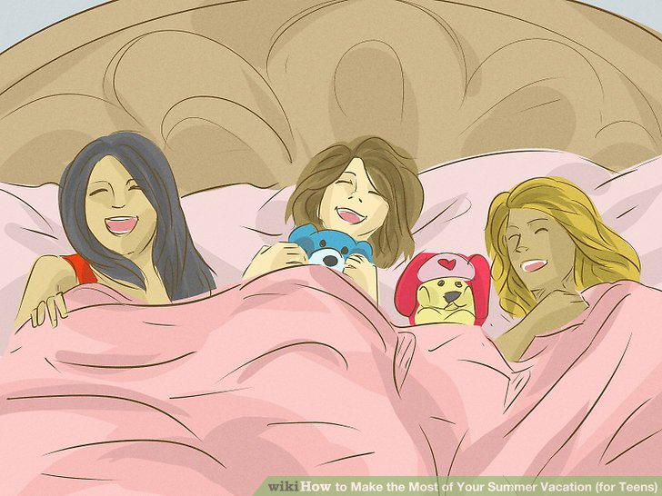

Invite some friends over and have an overnighter/sleepover. Grab your favourite drinks, snacks, movies, video games, magazines, and books to have a night full of fun.

