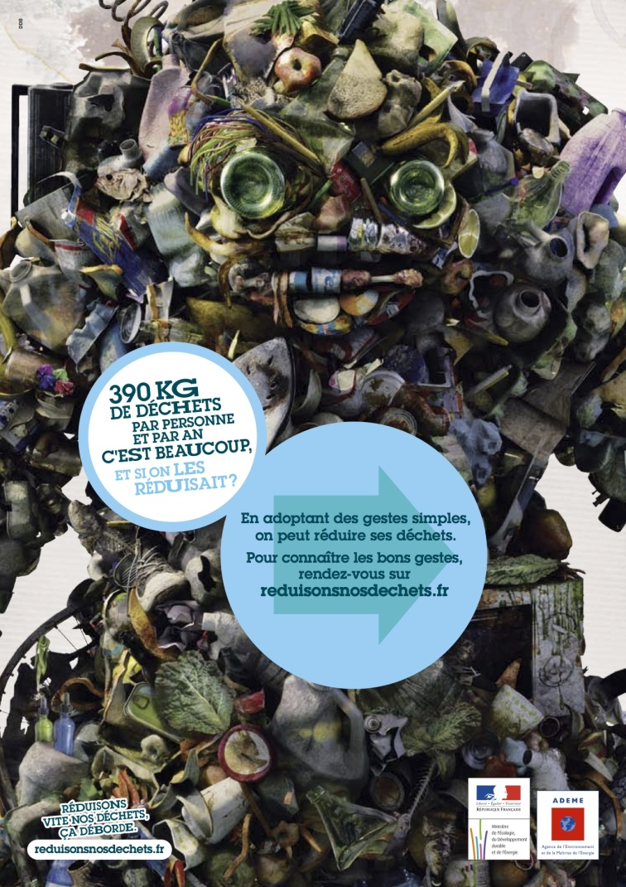
- Quelle est la nature du document ?
………………………………………………………………………………
- Quel est son message ?
………………………………………………………………………………………………………………………………………………………………………………………………………………………………………………
- Décris l’illustration du document
………………………………………………………………………………………………………………………………………………………………………………………………………………………………………………………………………………………………………………………………………………………………………………………………………………
- Propose des solutions pour réduire notre production de déchets.
……………………………………………………………………………………………………………………………………………………………………………………………………………………………………………………………………………………………………………………………………………………………………………………………………………………………………………………………………………………………………………………………………………………………………………………………………………………………………………………
……………………………………………………………………………………………………………………………………………………………………………………………………………………………………………………………………………………………………………………………………………………………………………………………………………………………………………………………………………………………………………………………………………………………………………………………………………………………………………………

