The film’s poster
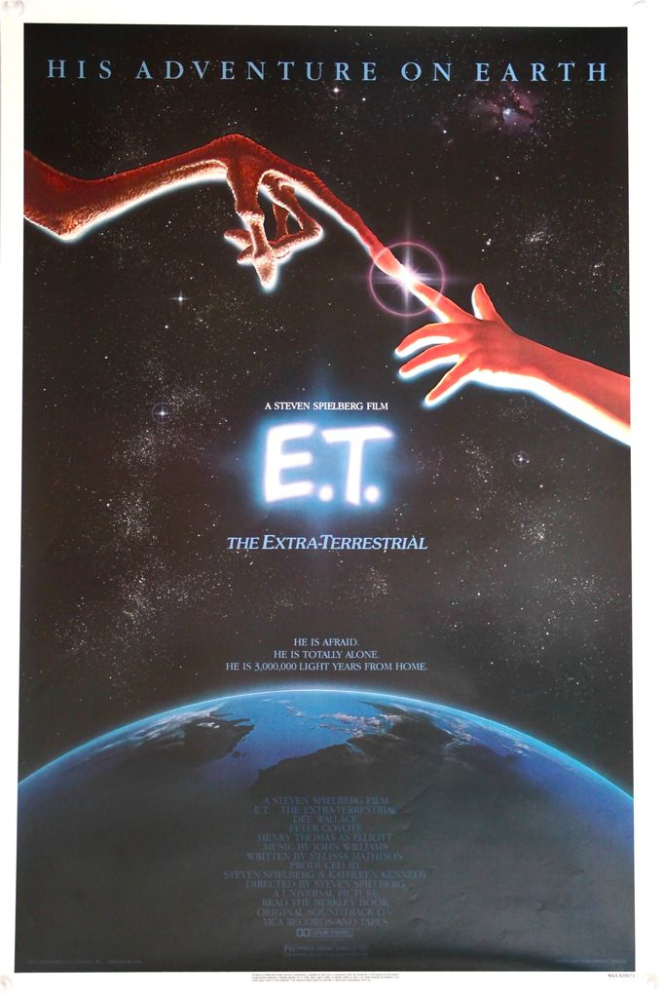

two characters : ET and Eliott

the director
the title

the actors
an actor/an actress

My opinion on the film (colour the stars) :

