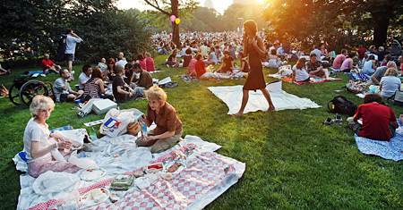

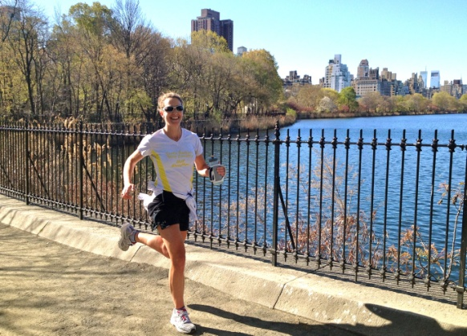

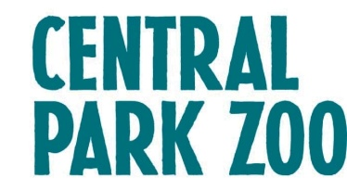
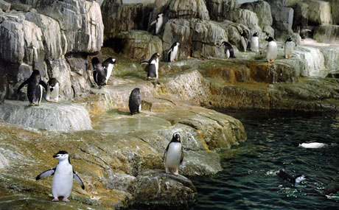

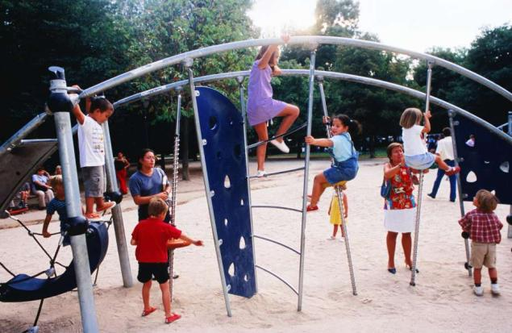
What is it ?
……………………………………………………………………………………………………………

What can we do there ?
……………………………………………………………………………………………………………………………………………………………………………………………………………………………………………………………………………………………………………………………………………………………………………………………………………………………………………………

How can we go there ?
………………………………………………………………………………………………………………………………………………………………………………………………………………………………………………………………………………………………………………………………………

