LOOKS
Woman | Man
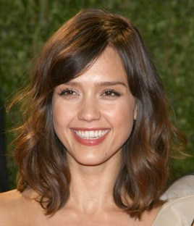  She is pretty  beautiful  cute | He is handsome  cute
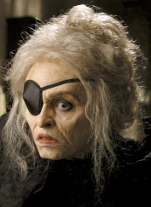
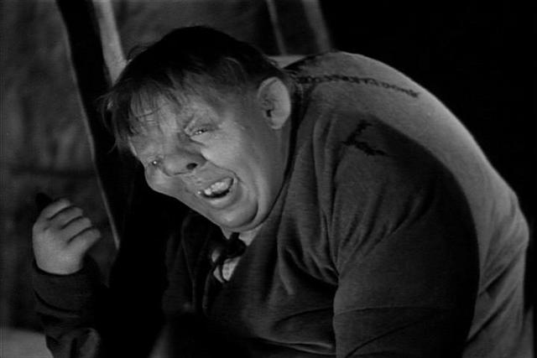

They are ugly.

LOOKS
Woman | Man
She is pretty  beautiful  cute | He is handsome  cute

They are ugly.

