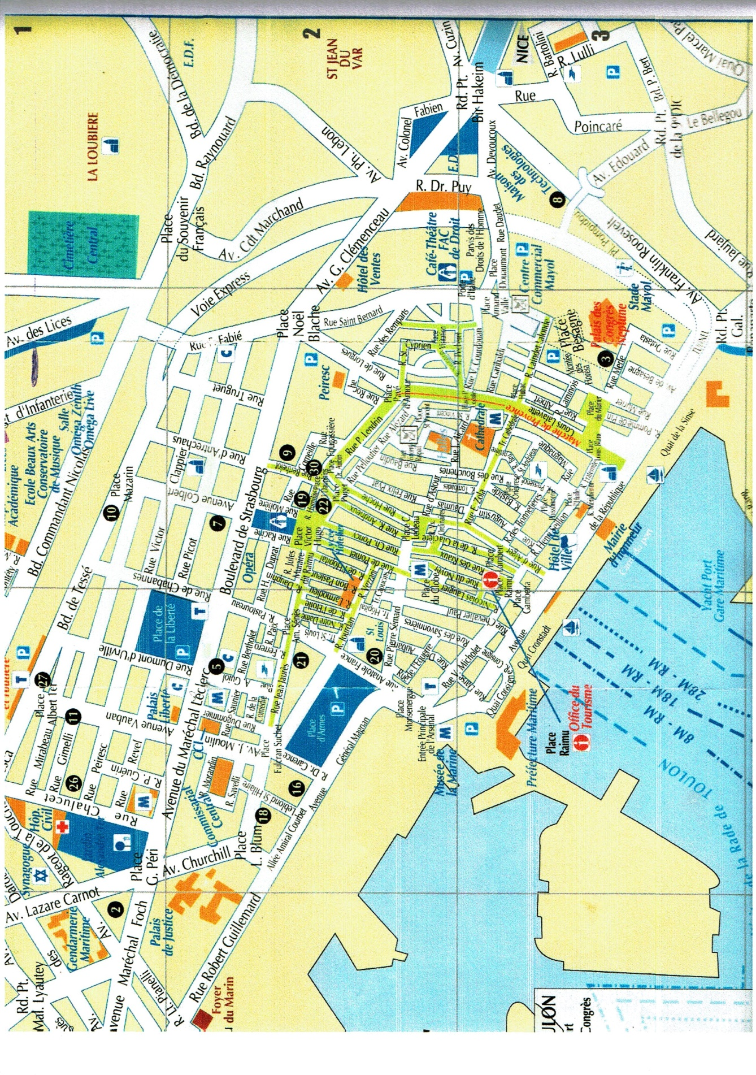

Palais Neptune

Salon Bacchus

Statue CUVERVILLe