1. **Mots fléchés du Petit Chaperon Rouge,**

**Ecriture**

Le

**Dessiné à la façon de Miró.**

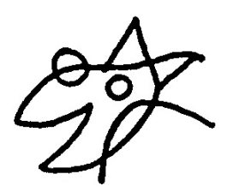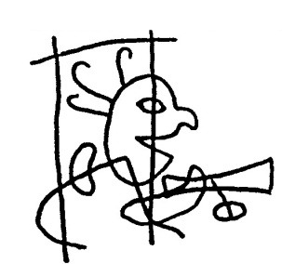

|  |  |  |  |  |  |  |  |  |  |  |  |  |  |  |  |  |  |
| --- | --- | --- | --- | --- | --- | --- | --- | --- | --- | --- | --- | --- | --- | --- | --- | --- | --- |
|  |  |  |  |  |  |  |  |  |  |  |  |  |  |  |  |  |  |
|  |  |  |  |  |  |  |  |  |  |  |  |  |  |  |  |  |  |
|  |  |  |  |  |  |  |  |  |  |  |  |  |  |  |  |  |  |
|  |  |  |  |  |  |  |  |  |  |  |  |  |  |  |  |  |  |
|  |  |  |  |  |  |  |  |  |  |  |  |  |  |  |  |  |  |
|  |  |  |  |  |  |  |  |  |  |  |  |  |  |  |  |  |  |
|  |  |  |  |  |  |  |  |  |  |  |  |  |  |  |  |  |  |
|  |  |  |  |  |  |  |  |  |  |  |  |  |  |  |  |  |  |
|  |  |  |  |  |  |  |  |  |  |  |  |  |  |  |  |  |  |
|  |  |  |  |  |  |  |  |  |  |  |  |  |  |  |  |  |  |
|  |  |  |  |  |  |  |  |  |  |  |  |  |  |  |  |  |  |
|  |  |  |  |  |  |  |  |  |  |  |  |  |  |  |  |  |  |
|  |  |  |  |  |  |  |  |  |  |  |  |  |  |  |  |  |  |

1. 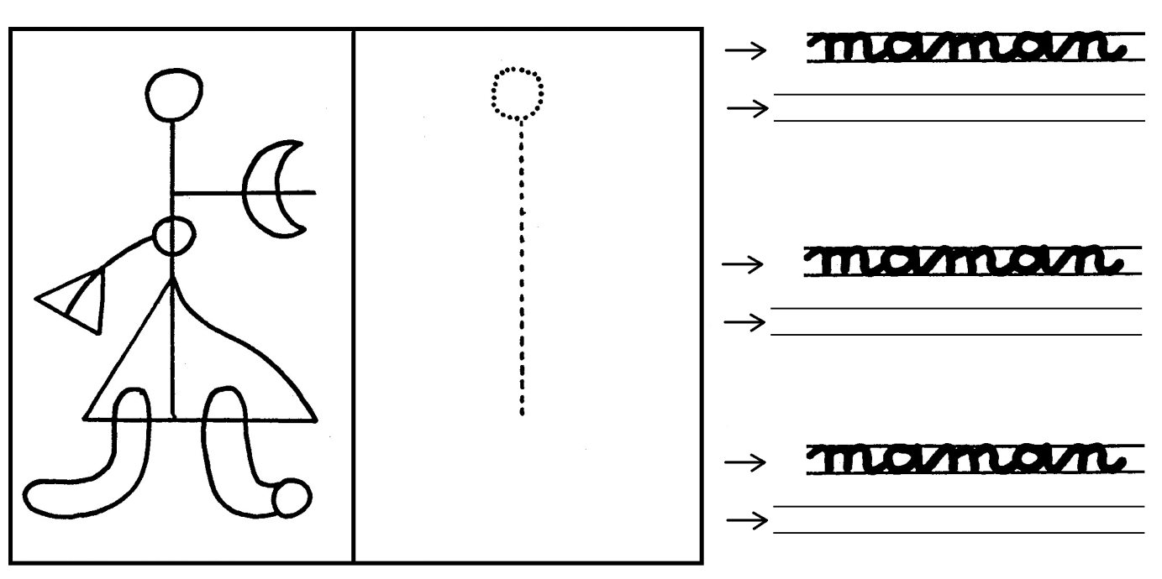**Dessine et écris.**