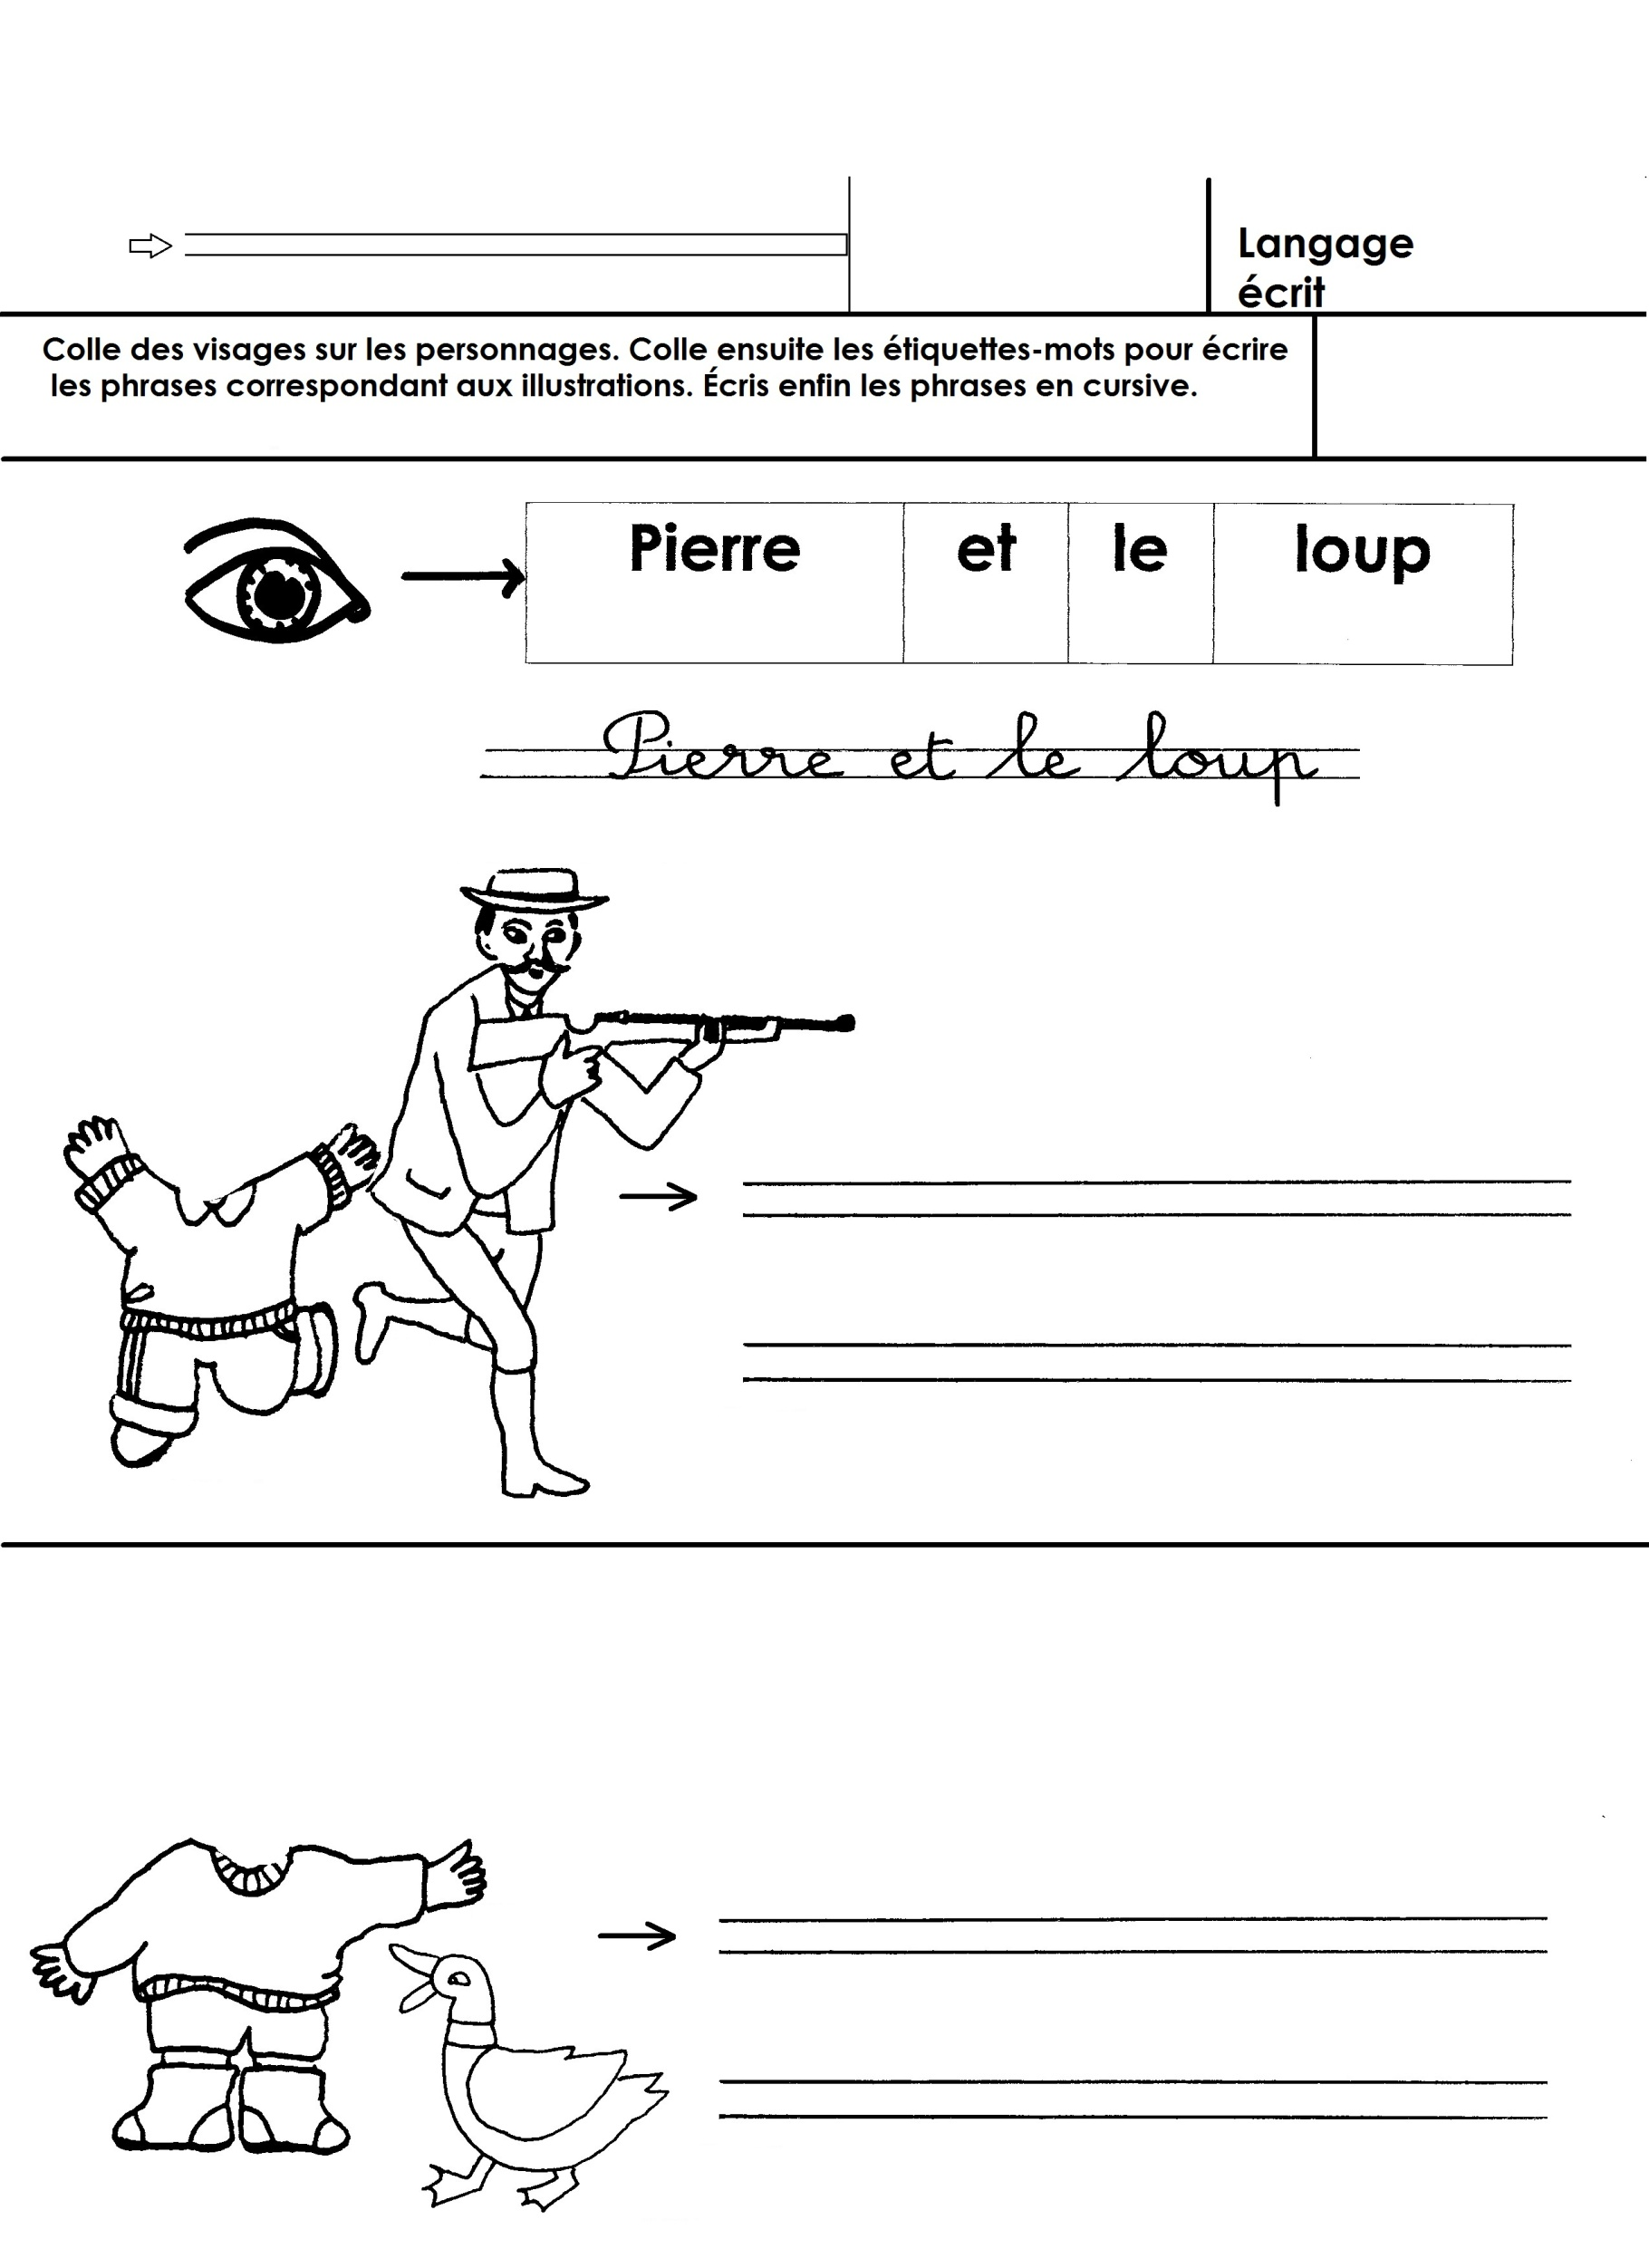

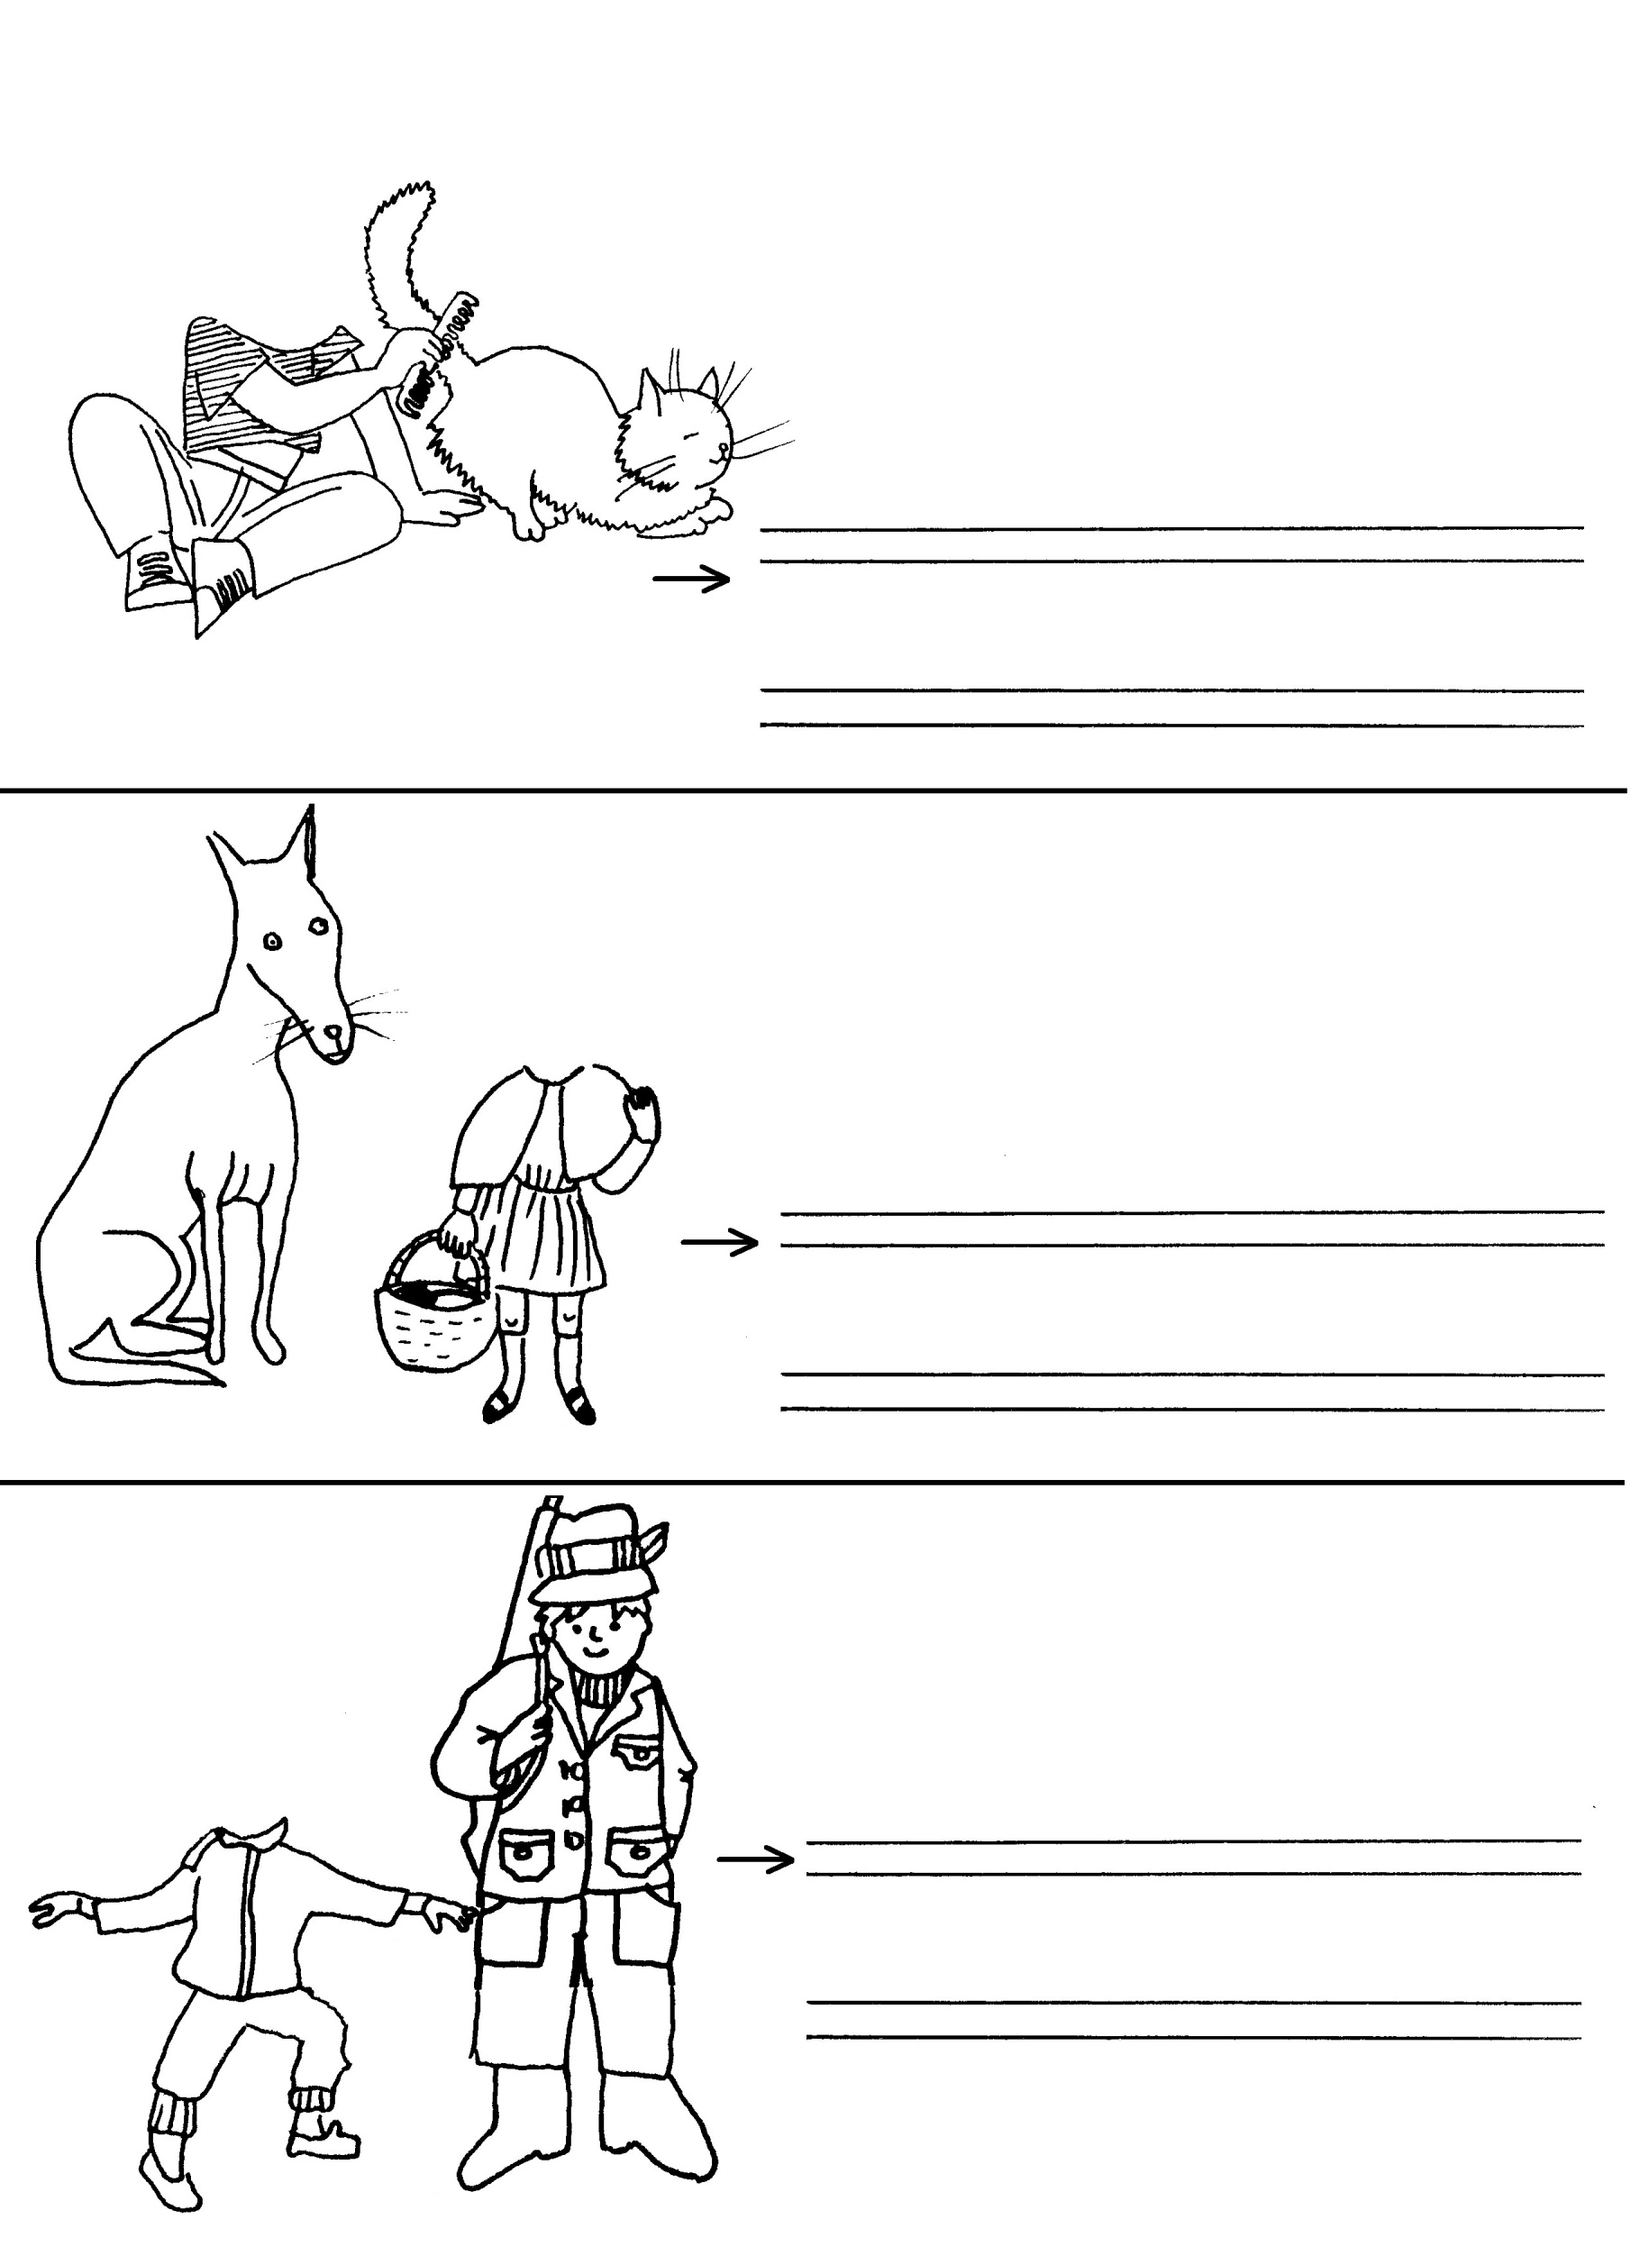

|  |  |  |  |  |  |  |
| --- | --- | --- | --- | --- | --- | --- |
| **chasseur** | **et** | **le** |  |  |  | |
| **chasseur** | **et** | **le** |  |  |  | |
| **canard** | **et** | **le** |  |  |  |  |
| **loup** | **et** | **le** |  |  |  | |
| **chat** |  | |  |  |  | |