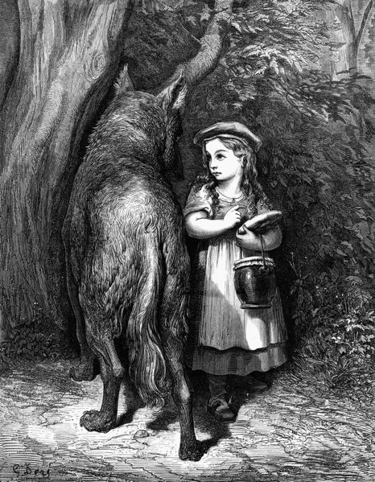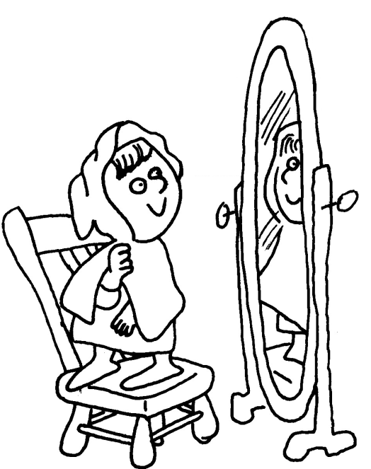

Le

Colle les lettres en script et en cursive sous le modèle.

Langage écrit

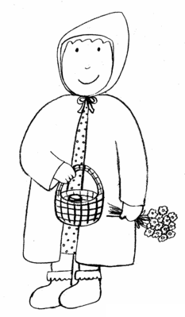

|  |  |  |  |  |  |  |  |  |  |  |  |  |  |  |  |  |  |  |  |
| --- | --- | --- | --- | --- | --- | --- | --- | --- | --- | --- | --- | --- | --- | --- | --- | --- | --- | --- | --- |
| **P** | **E** | **T** | **I** | **T** |  | **C** | **H** | **A** | **P** | **E** | **R** | **O** | **N** |  | **R** | **O** | **U** | **G** | **E** |
|  |  |  |  |  |  |  |  |  |  |  |  |  |  |  |  |  |  |  |  |
|  |  |  |  |  |  |  |  |  |  |  |  |  |  |  |  |  |  |  |  |

|  |  |  |  |  |  |  |  |  |  |  |  |  |  |  |  |  |  |  |  |
| --- | --- | --- | --- | --- | --- | --- | --- | --- | --- | --- | --- | --- | --- | --- | --- | --- | --- | --- | --- |
| **h** | **e** | **c** | **r** | **p** | **t** | **a** | **n** | **o** | **t** | **p** | **u** | **i** | **e** | **o** | **r** | **e** | **g** |  |  |
|  |  |  |  |  |  |  |  |  |  |  |  |  |  |  |  |  |  |  |  |