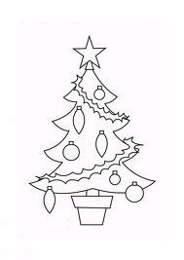

Le

Transcris les mots en majuscules.

Langage écrit

|  |  |  |  |  |  |  |  |  |  |  |  |
| --- | --- | --- | --- | --- | --- | --- | --- | --- | --- | --- | --- |
| **s** | **a** | **p** | **i** | **n** |  |  | **b** | **o** | **u** | **l** | **e** |
|  |  |  |  |  |  |  |  |  |  |  |  |

