**Saisons des fruits et légumes**

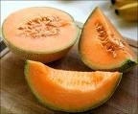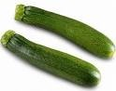

|  |  |  |  |  |  |  |  |
| --- | --- | --- | --- | --- | --- | --- | --- |
| **Automne** | Photos |  |  |  |  |  |  |
| Noms | Champignon | Endive | Poire | Concombre |  |  |
| Astuces  Définitions |  |  |  |  |  |  |
| **Hiver** | Photos |  |  |  |  |  |  |
| Noms | Asperge | Fraise | Carotte |  |  |  |
| Astuces  Définitions |  |  |  |  |  |  |
| **Printemps** | Photos |  |  |  |  |  |  |
| Noms | Cerise | Salade | Chou-fleur |  |  |  |
| Astuces  Définitions |  |  |  |  |  |  |
| **Ete** | Photos |  |  |  |  |  |  |
| Noms | Raisin | Pampplemousse | Kiwi | Orange | Tomate | Ananas |
|  |  |  |  |  |  |  |

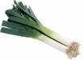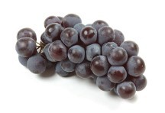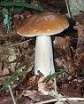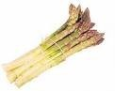

**En français** Asperge Champignon Raisin Ananas Endive

Radis

Citrouille

Nectarine

Melon

Cerise

Concombre

Poireau

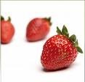

Chou-fleur

Poire

Carotte

Orange

Kiwi

Tomate Courgette Pamplemousse

Pêche

Fraise

Salade

**En anglais**

Grapefruit

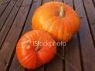

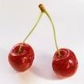Peach

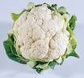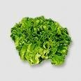

Pear

Cucumber

Orange

Lettuce Tomato Cauliflower

Leek

Radish

Cherry

Chicory

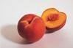

Pumpkin

Melon

Nectarine

Kiwi

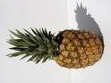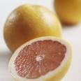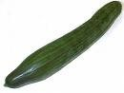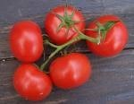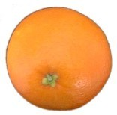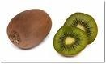

Asparagus

Strawberry

Mushroom

Pineapple Carrot Grapes

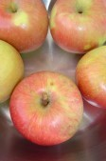

Orange

zucchini

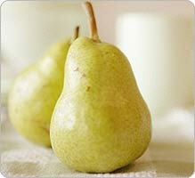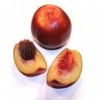

Astuces

Définitions

