Alexander Calder  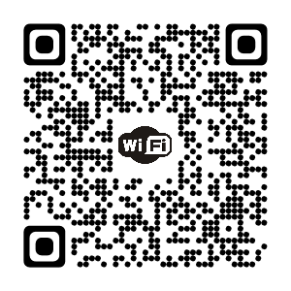 | Alexander Calder | Alexander Calder
Alexander Calder | Alexander Calder | Alexander Calder
Alexander Calder | Alexander Calder | Alexander Calder
Alexander Calder | Alexander Calder | Alexander Calder
Alexander Calder | Alexander Calder | Alexander Calder

