The unsuitable house of my neighborhood
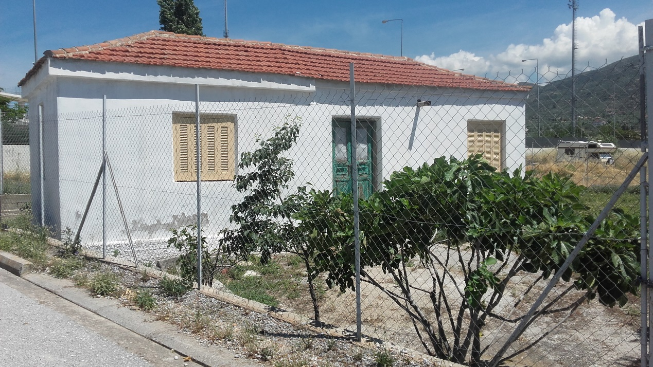
It is located in a regional neighborhood of Volos. The house isn’t suitable because it is too old for the location that is situated.
This is the neighborhood
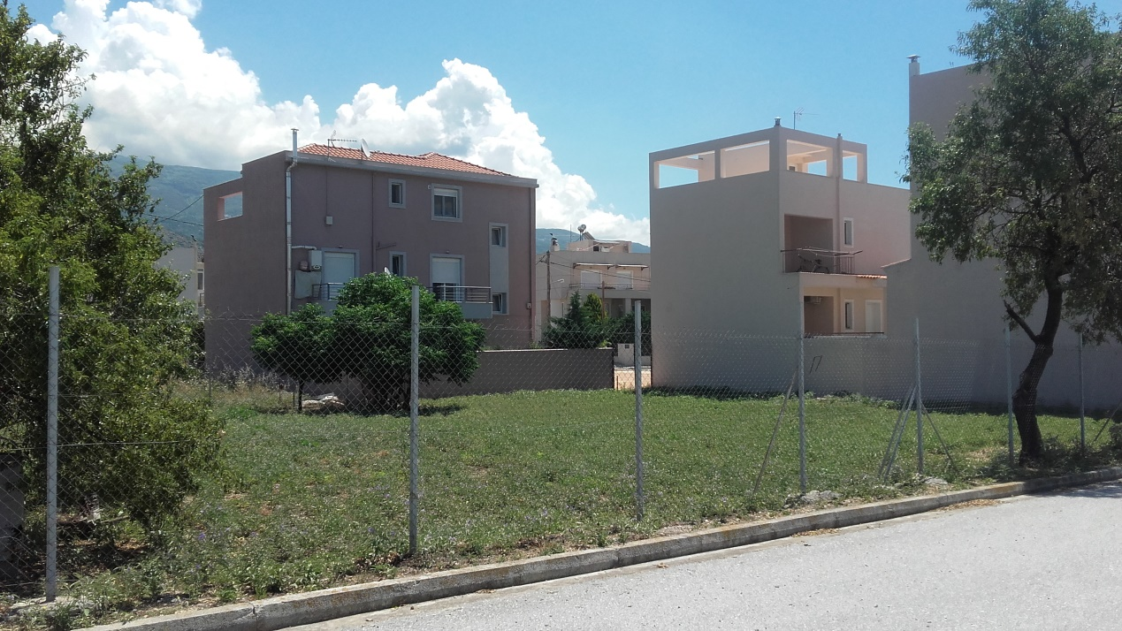
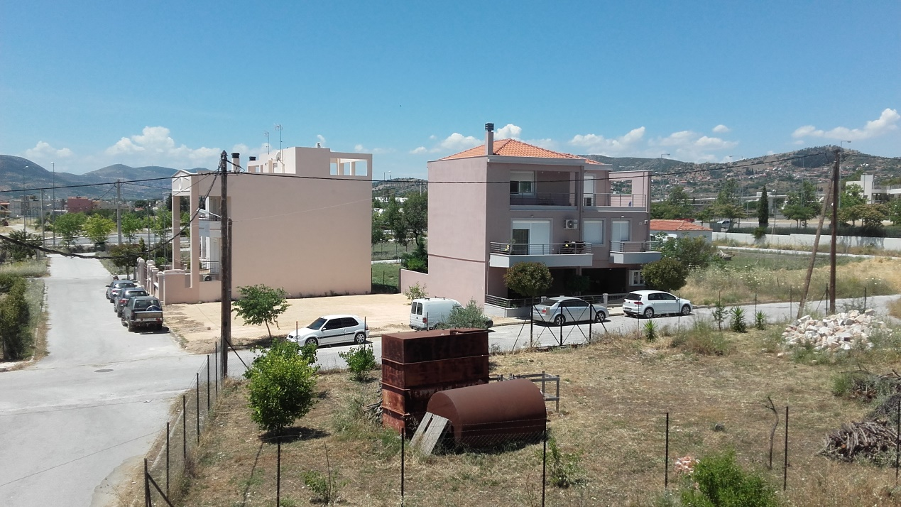

And this is the house that I would recommend in order to replace the unsuitable house according to the architectural plan of the area.
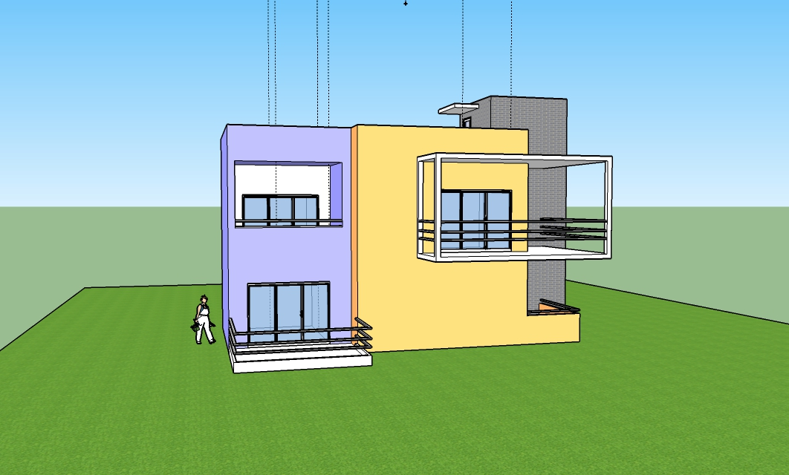
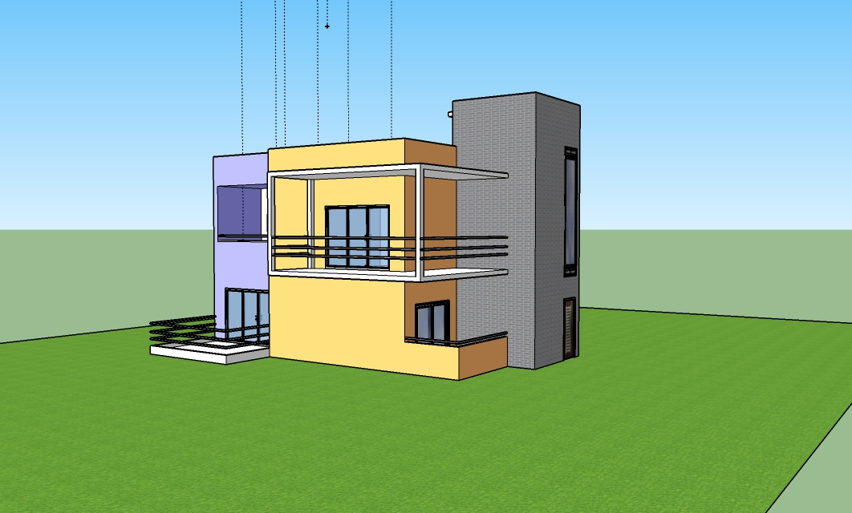
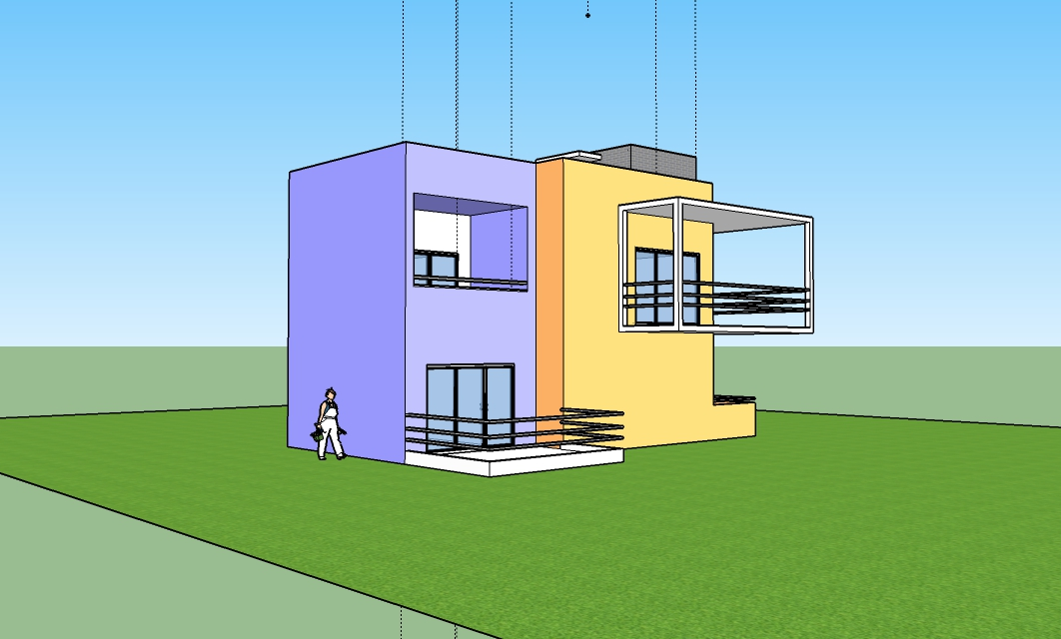
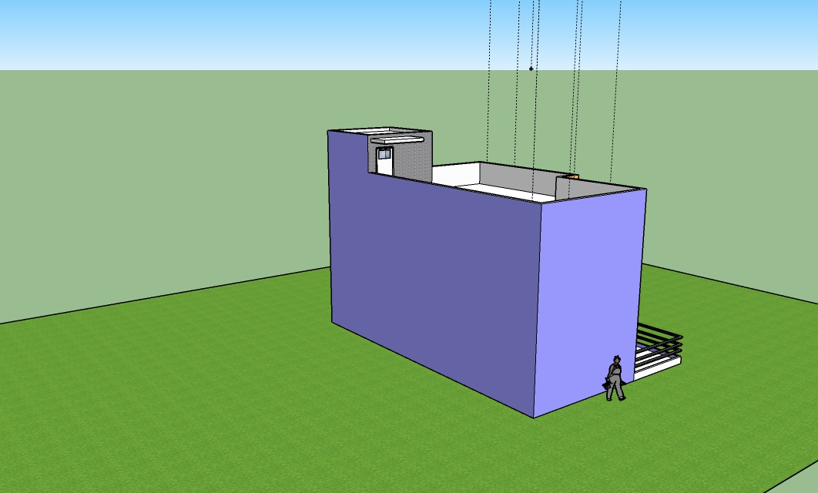
The materials that I used in order to make this new house are ;
- Brick Colored Blue
- Aluminum
- 3 Pane Aluminum Framed Window with center Sliding Door
- Aluminum Sliding Door
- Malaysia Safety Door
- Grass dark green
- Color C03
- Color I02
- Color M00

