ERASMUS +

As you walk through the streets of Volos, you can see many beautiful houses. But sometimes , right next to a beautiful house, is build an ugly one.
JUST LIKE THIS:
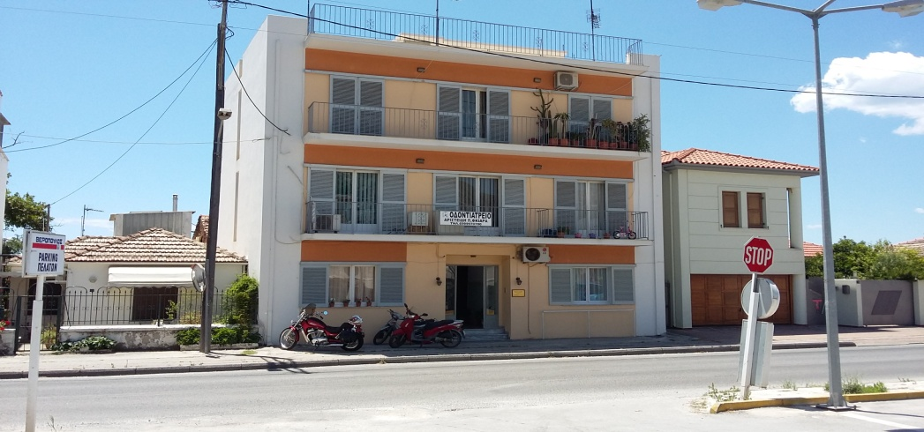

The project of Erasmus+, asked all of us to sketch a new house, that fits better with the other houses, and replace it.
THE HOUSE THAT I SKETCHED, ENDS UP LIKE THIS:
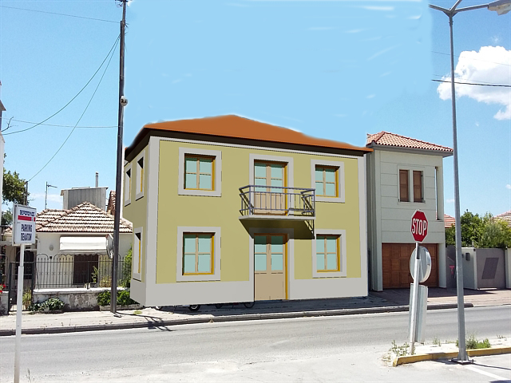

The materials that I used were:
Glass, wood , white and yellow plaster and metal.

I hope you like it and thank you very much for your time !
-Anna Voyatzi

