EYE OF THE TIGER
(Survivor)

INTRODUCTION CLAVIER:
I) DO DO Sib DO DO Sib DO DO Sib Lab (M.D+MG.)

II) Mib MIb RE MIb MIb RE MIb MIb RE DO (M.D.)
DO DO Sib DO DO Sib DO DO Sib Lab(M.D+MG.)

III) SOL SOL FA SOL SOL FA SOL SOL FA MIb (M.D.)
Mib MIb RE MIb MIb RE MIb MIb RE DO (M.D.)
DO DO Sib DO DO Sib DO DO Sib Lab(M.D+MG.)

INTRODUCTION BASSE:
- DO : 5ème corde 3ème case
- SIb : 5ème corde 1ère case
- LAb : 6ème corde 4ème case

Risin' up, back on the street ‘
Did my time, took my chances ‘
Went the distance, now I'm back on my feet ‘
Just a man and his will to survive ‘
So many times, it happens too fast ‘
You change your passion for glory ‘
Don't lose your grip on the dreams of the past ‘
You must fight just to keep them alive ‘
REFRAIN :
It's the ‘ eye of the tiger, it's the cream of the fight ‘
Risin' up to the challenge of our rival ‘
And the last known survivor stalks his prey in the night ‘
And he's watchin' us all in the eye ‘ of the tiger ‘
Face to face, out in the heat ‘
Hangin' tough, stayin' hungry ‘
They stack the odds 'til we take to the street ‘
For we kill with the skill to survive ‘
Refrain

Risin' up, straight to the top ‘
Have the guts, got the glory ‘
Went the distance, now I'm not gonna stop ‘
Just a man and his will to survive ‘

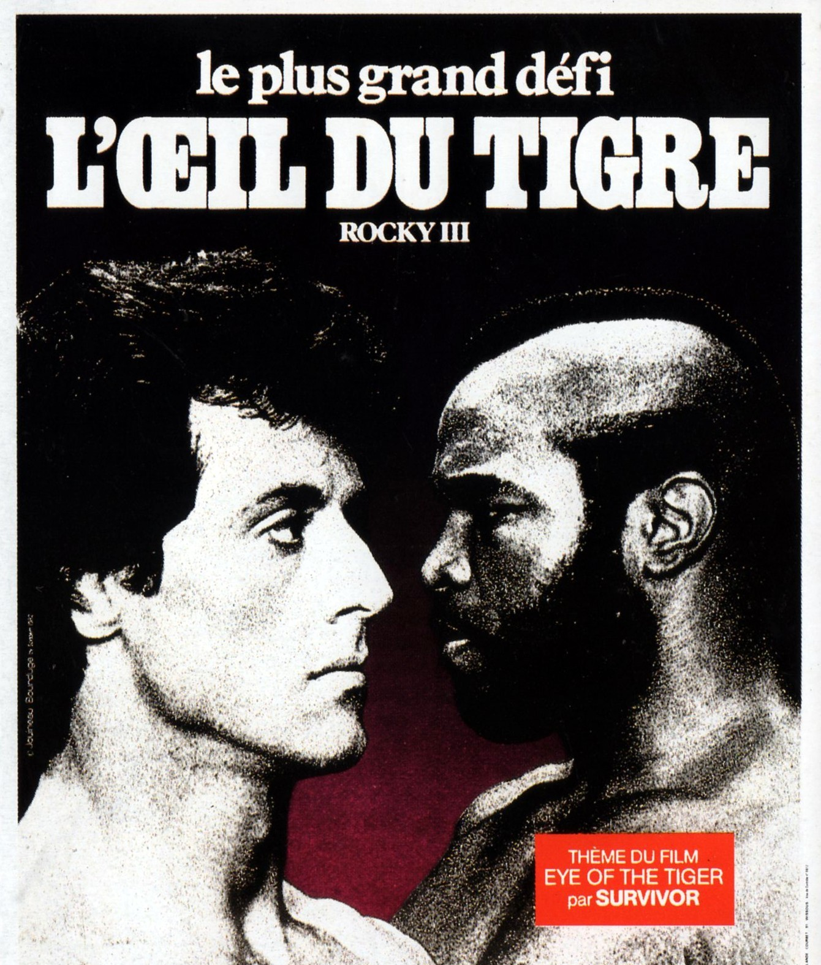

EYE OF THE TIGER
(Survivor)

INTRODUCTION CLAVIER:
I) DO DO Sib DO DO Sib DO DO Sib Lab (M.D+MG.)

II) Mib MIb RE MIb MIb RE MIb MIb RE DO (M.D.)
DO DO Sib DO DO Sib DO DO Sib Lab(M.D+MG.)

III) SOL SOL FA SOL SOL FA SOL SOL FA MIb (M.D.)
Mib MIb RE MIb MIb RE MIb MIb RE DO (M.D.)
DO DO Sib DO DO Sib DO DO Sib Lab(M.D+MG.)

INTRODUCTION BASSE:
- DO : 5ème corde 3ème case
- SIb : 5ème corde 1ère case
- LAb : 6ème corde 4ème case

Risin' up, back on the street ‘
Did my time, took my chances ‘
Went the distance, now I'm back on my feet ‘
Just a man and his will to survive ‘
So many times, it happens too fast ‘
You change your passion for glory ‘
Don't lose your grip on the dreams of the past ‘
You must fight just to keep them alive ‘
REFRAIN :
It's the ‘ eye of the tiger, it's the cream of the fight ‘
Risin' up to the challenge of our rival ‘
And the last known survivor stalks his prey in the night ‘
And he's watchin' us all in the eye ‘ of the tiger ‘
Face to face, out in the heat ‘
Hangin' tough, stayin' hungry ‘
They stack the odds 'til we take to the street ‘
For we kill with the skill to survive ‘
Refrain

Risin' up, straight to the top ‘
Have the guts, got the glory ‘
Went the distance, now I'm not gonna stop ‘
Just a man and his will to survive ‘

