Summer nights (extrait de la comédie musicale Grease )
Paroles et musique : Warren Casey et Jim Jacobs

NOTE OBTENUE : /20
Main droite

Main gauche
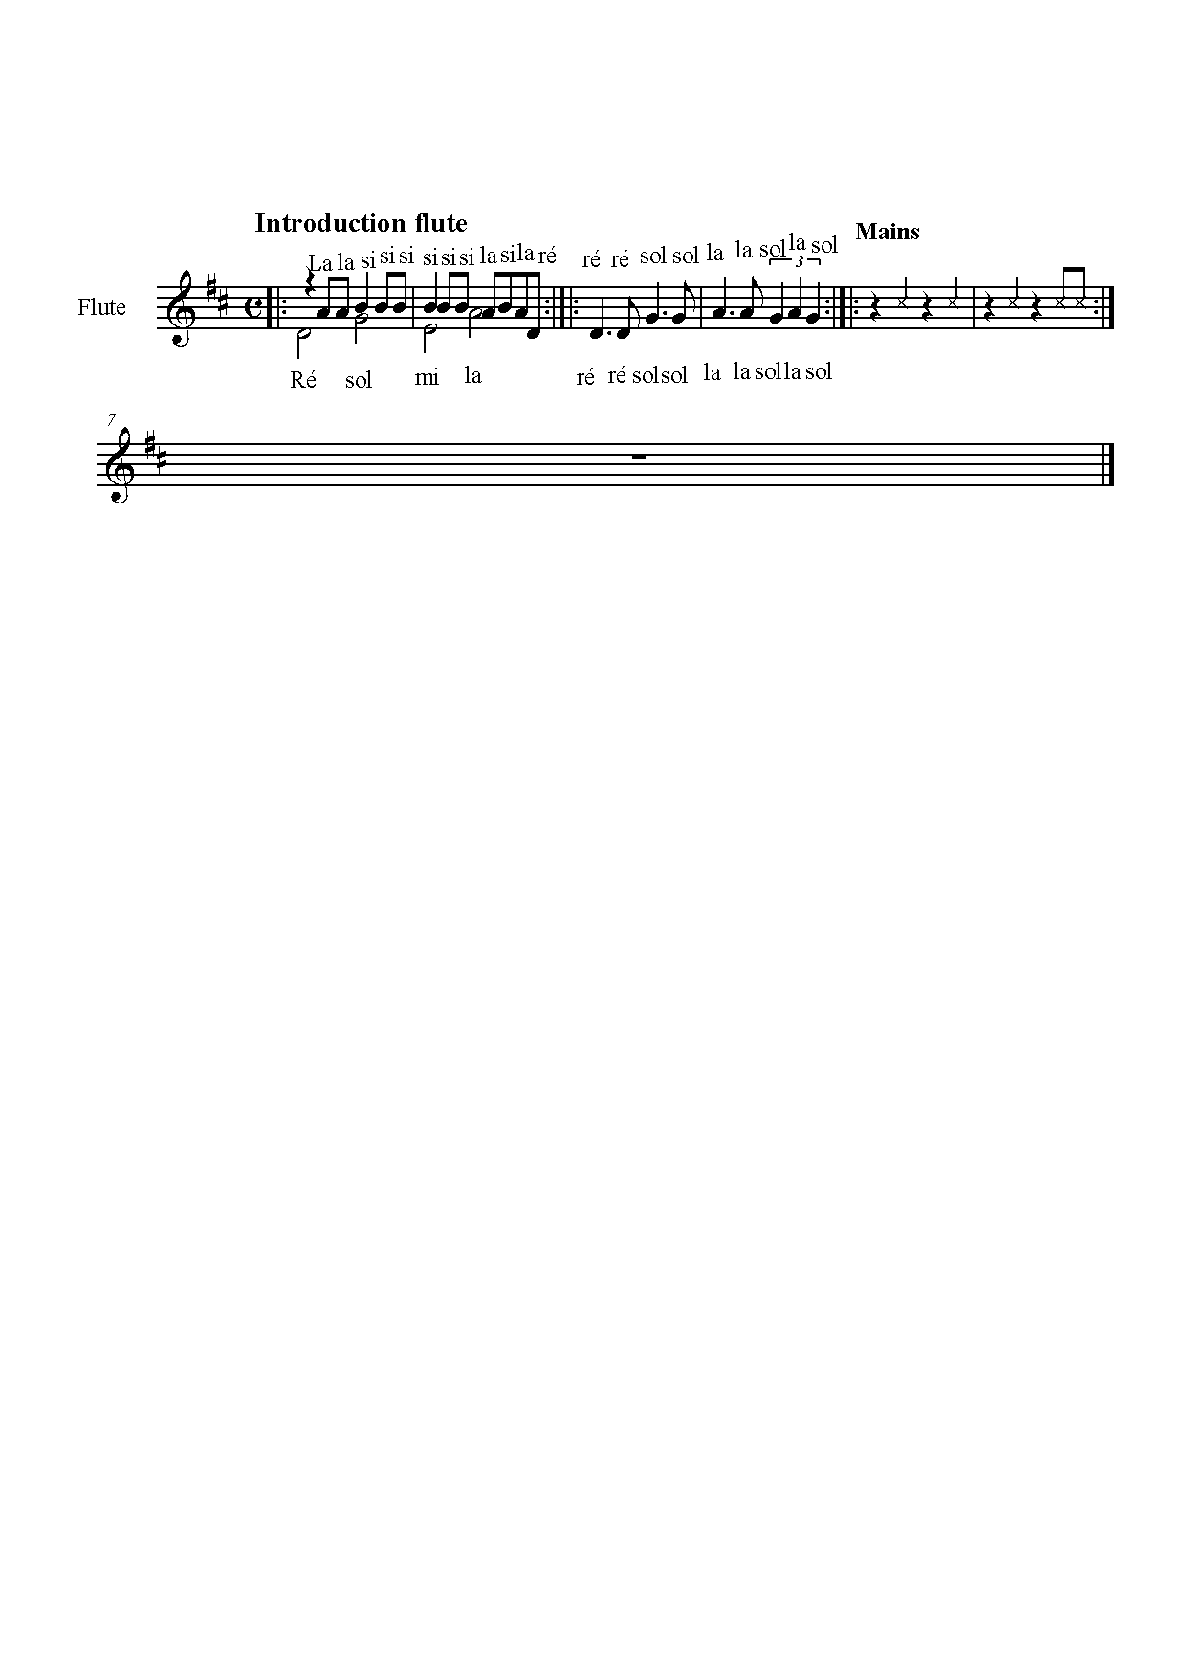

G: Summer loving had me a blast
F: Summer loving happened so fast
G: I met a girl crazy for me
F: Met a boy cute as can be
2: Summer days drifting away to oh oh the summer nights, oh well oh well oh well oh hou!

G: Tell me more, tell me more, did you get very far?
F: Tell me more, tell me more, like does he have a car? ( G: Shoubidop bop... F: Hein hein...)

G: She swam by me, she got a cramp
F: He ran by me, got my suit damp
G: I saved her life, she nearly drown
F: He showed off, splashing around
2: Summer sun somethings begun but oh oh the summer nights, oh well oh well oh well oh hou!

F: Tell me more, tell me more, was it love at first sight?
G: Tell me more, tell me more, did she put up a fight? ( G: Shoubidop bop... F: Hein hein...)

G: Took her bowling in the arcade
F: We went strolling drank lemonade
G: We made out under the dock
F: We stayed out ‘till ten o’clock
2: Summer fling don’t mean a thing but oh oh the summer nights (aigu) oh oh oh!

G: Tell me more, tell me more but you don’t gotta brag
F: Tell me more, tell me more cause he sounds like a drag ( G: Shoubidop bop... F: Hein hein...)

F: He got friendly holding my hand
G: She got friendly down in the sand
F: He was sweet just turned eightteen
G: She was good, you know what I mean
2: Summer heat, boy and girl meet but oh oh the summer nights (aigu)

F: Tell me more, tell me more, how much dough did he spend?

G: Tell me more, tell me more, could she get me a friend? (STOP)

F (lent): It turned colder, that’s where it ends
G: So I told her we’d still be friends

F: Then we made our true love vow
G: Wonder what she’s doing now…

2: Summer dreams ripped at the seams but oh those summer (STOP) ni.......ghts
Tell me more tell me more oh oh!

