LINCOLN, THE MOVIE

TYPE OF FILM

It is a historical drama. It deals with historical facts – real facts – but the director may have changed some elements for the purpose of the movie. It is not entirely reliable.

PLOT

It covers the final four months of Abraham Lincoln. It shows how Lincoln fought from January to April (when he was assassinated) to have the 13th Amendment to the US Constitution passed by the House of Representatives.

DIRECTOR AND PRODUCER

Steven Spielberg (ET, Saving Private Ryan, Schindler’s List). He is a very famous American director and producer.

CAST

Lincoln part / Lead actor ➔ Daniel Day-Lewis (Gangs of New York, The Last of the Mohicans)
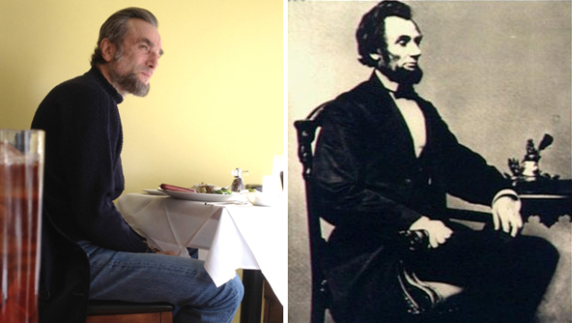

First Lady Mary Todd Lincoln (his wife) ➔ Sally Field (Forrest Gump, Mrs Doubfire)
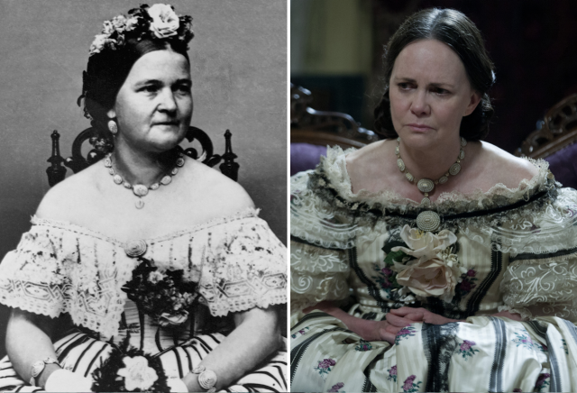

Thaddeus Stevens (Member of the House of Representatives: against slavery) ➔  Tommy Lee Jones
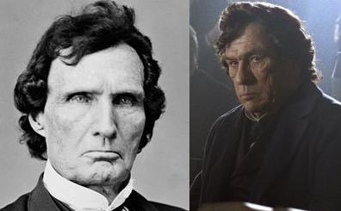
Who was Abraham Lincoln? What’s the Civil War?

Abraham Lincoln (1809 – April 1865) was the 16th President of the United States, in office from March 1861 until his assassination in April 1865.

He was married to Mary Todd Lincoln. They had fours sons but only one survived through childhood: Robert Todd Lincoln. We also see Tad Lincoln in the movie (he died at 18).

He was the first president from the Republican Party. He was in office during the Civil War (1861-1865), which took place between the Northern States (the Union) and the Southern States (the Confederacy). The Confederacy seceded (French name for the war: Guerre de Secession) from the Union and set up their own government in 1861.

UNION TROOPS: they wear blue uniforms

CONFEDERACY: they wear grey uniforms

Abraham Lincoln wanted to end slavery = he wanted to abolish slavery. This is one of the many causes of the Civil War.

The 13th Amendment to the Constitution of the US

Passed by Congress on January 31, 1865, and ratified on December 6, 1865, the 13th amendment abolished slavery in the United States.

TEXT

Section 1. Neither slavery nor involuntary servitude, except as a punishment for crime whereof the party shall have been duly convicted, shall exist within the United States, or any place subject to their jurisdiction.
Section 2. Congress shall have power to enforce this article by appropriate legislation.

The 13th Amendment completed the abolition of slavery started with Lincoln’s Emancipation Proclamation of 1863, which freed slaves. It inscribes the abolition of slavery in the Constitution. Lincoln feared that the Confederates should consider the freedom of slaves as a temporary measure.

