



|  |  |
| --- | --- |
| ESTUDIANTES | EDAD |
| KARL CHICA | 15 |
| ISAAC YEPES | 15 |
| EDGAR CUADRO | 16 |
| JEAN KARLO SANCHEZ | 16 |
| GIANNINA PALACIO | 14 |
| SHARON SUAREZ | 16 |
| MAURICIO BARROS | 16 |
|  |  |

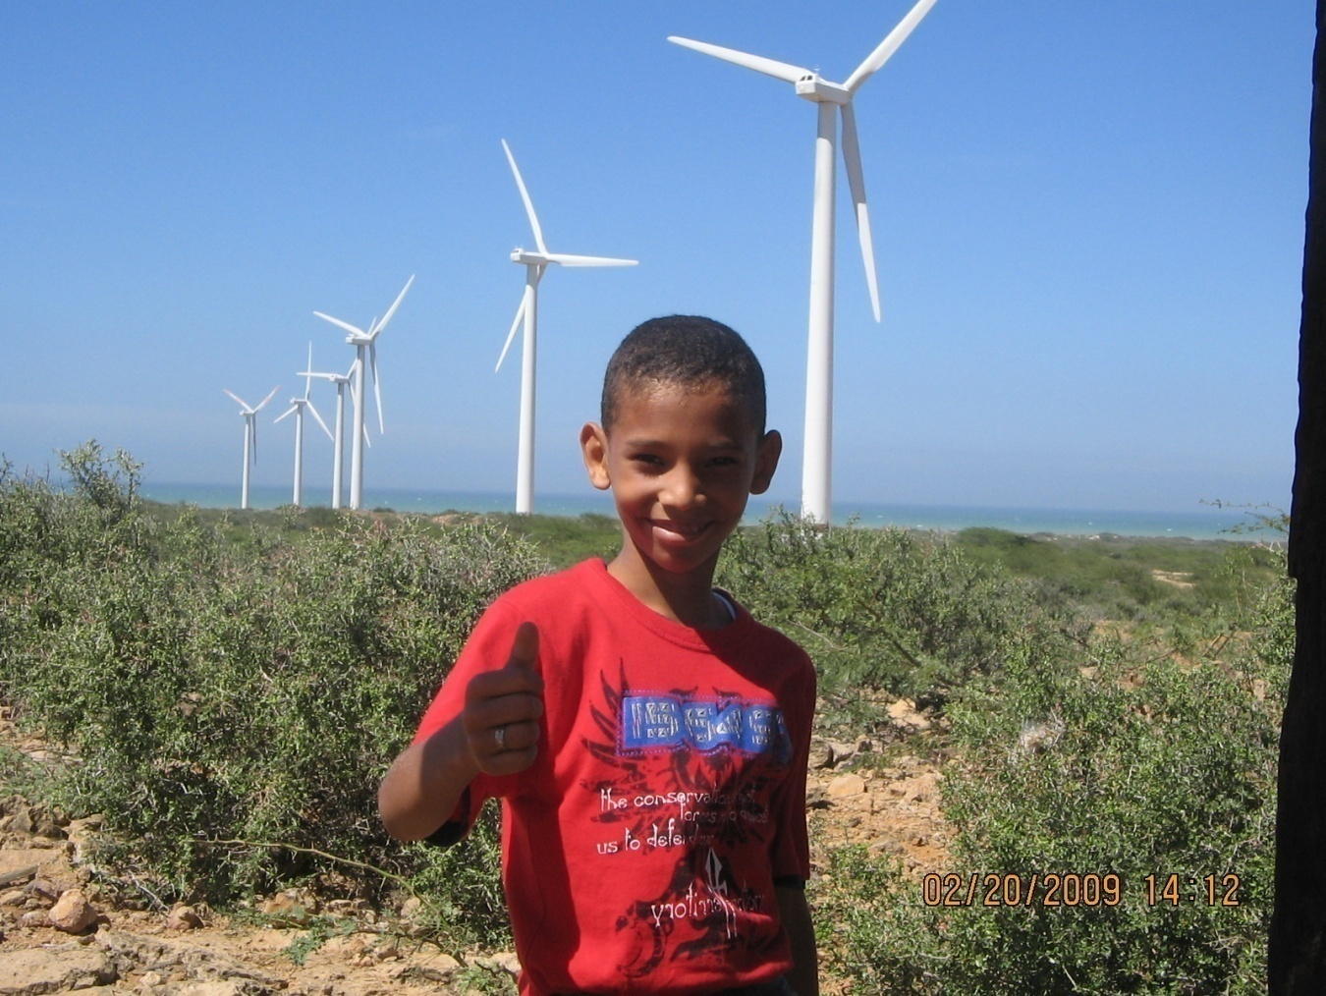

KARL CHICA DAMIAN EN JEPIRACHI

GRAFICA



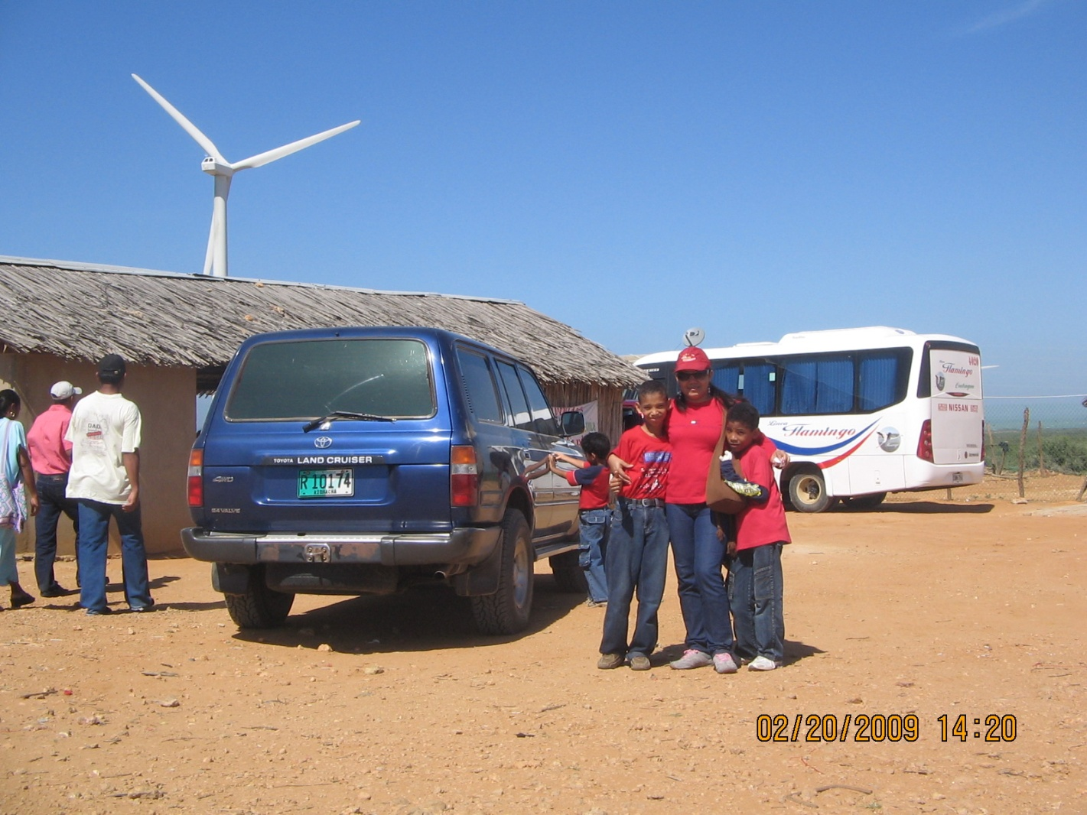

C:\Program Files\Microsoft Office\MEDIA\CAGCAT10\j0281904.wmf